Acceptance Testing

UAT Execution & Report Submission

|  |  |
| --- | --- |
| **Date** | 19 November 2022 |
| **Team ID** | PNT2022TMID48272 |
| **Project Name** | Statistical Machine Learning Approaches To Liver Disease Prediction |
| **Maximum Marks** | 4 Marks |

# Purpose of Document

The purpose of this document is to briefly explain the test coverage and open issues of the project-statistical machine learning approaches to liver disease prediction at the time of the release to User Acceptance Testing (UAT).

# Defect Analysis

This report shows the number of resolved or closed bugs at each severity level, and how they were resolved

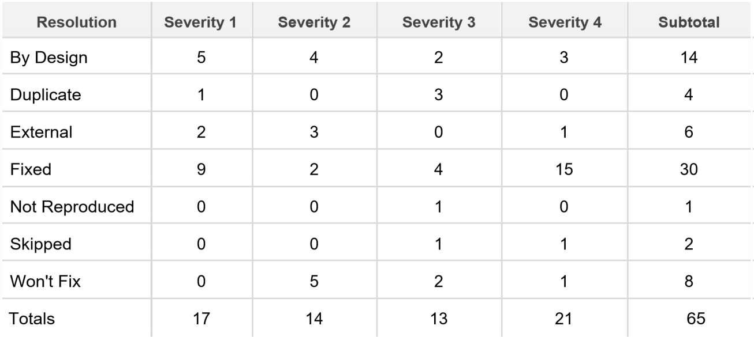

# Test Case Analysis

This report shows the number of test cases that have passed, failed, and untested

